Massive Dynamic

Diagram documentation

Borrow My Books System

Contents

Purchase Sequence Diagram: 2

Contact Admin sequence diagram: 3

Contact User sequence diagram: 4

Update user details sequence diagram: 5

Discount Evaluation Sequence Diagram: 6

Explore Sequence Diagram: 7

Loan Sequence Diagram: 8

Login sequence diagram: 9

Logout sequence diagram: 10

Profile Sequence Diagram: 11

Rent sequence diagram: 12

Report User Sequence Diagram 13

Reset Password sequence diagram: 14

Reverse Transaction Sequence Diagram 15

View uploaded books sequence diagram: 16

Sell sequence diagram 17

Sign up sequence diagram: 18

System defaults sequence diagram 19

System information sequence diagram 20

# Purchase Sequence Diagram:

The sequence diagram below describes the process which the system follows when a user is requesting to make a purchase of a specific book.

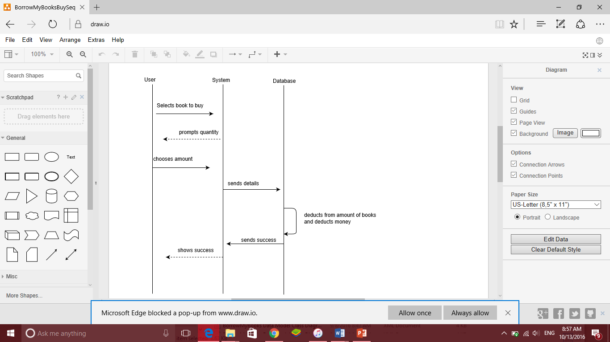

The purchaser selects a book which they would like to buy. The user is then prompted to enter the quantity of the specific book which they would like to purchase. Once the quantity is entered, the database inventory and balance is updated. The user is then informed of the successful transaction made.

# Contact Admin sequence diagram:

The following sequence diagram describes the process followed by the system when a user requests to come into contact with an administrator.

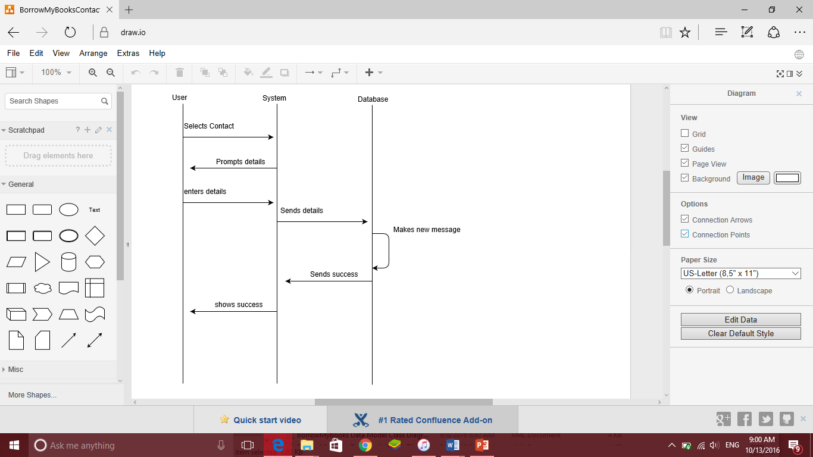

The user selects the option to contact an administrator. The system then asks the user for their personal details, and these details are sent to the database which creates a message. The user is then informed that their request was submitted successfully.

# Contact User sequence diagram:

The following sequence diagram shows the process of the system contacting a user with the administrator’s response to the system request.

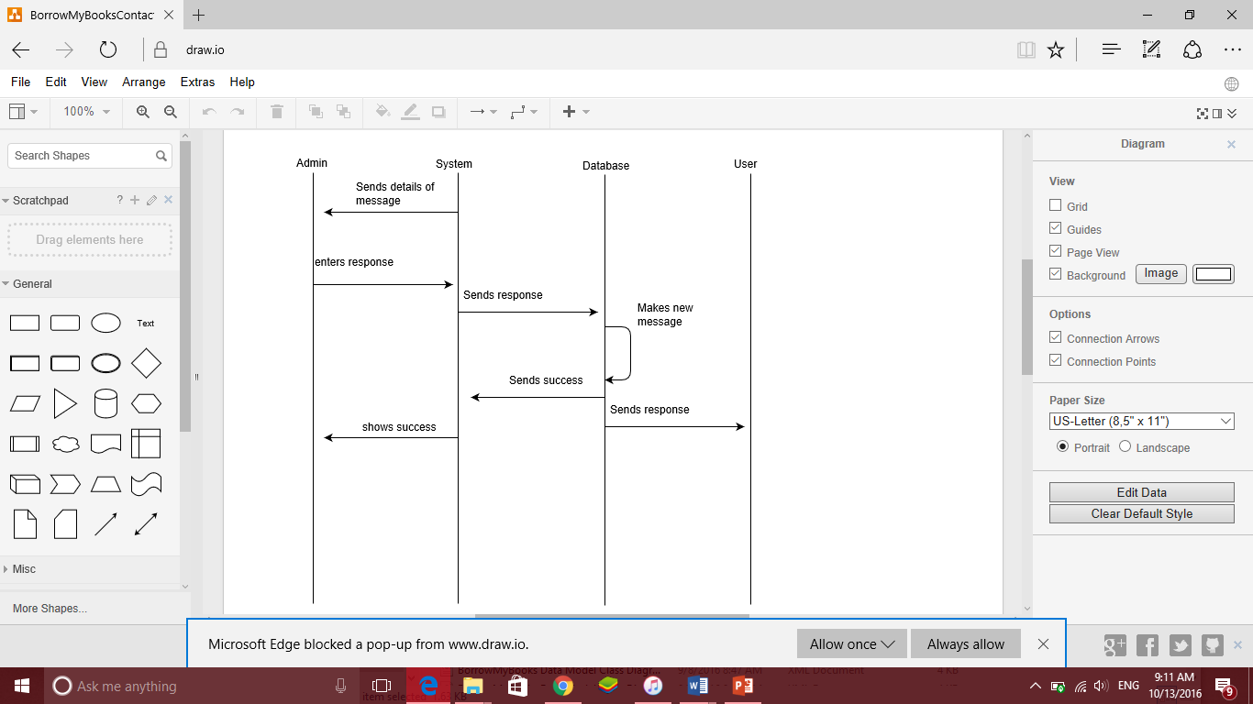

The system needs to send a notification to a user. Therefore, it sends a message to the administrator with the nature of the message to be sent. The administrator responds to this request. The system then sends the response to the database. A new message is then generated and sent to the user and a success notification is sent to the system and forwarded to the administrator.

# Update user details sequence diagram:

The following sequence diagram depicts the process followed by the system and user upon the user’s request to update their details in the systems database.

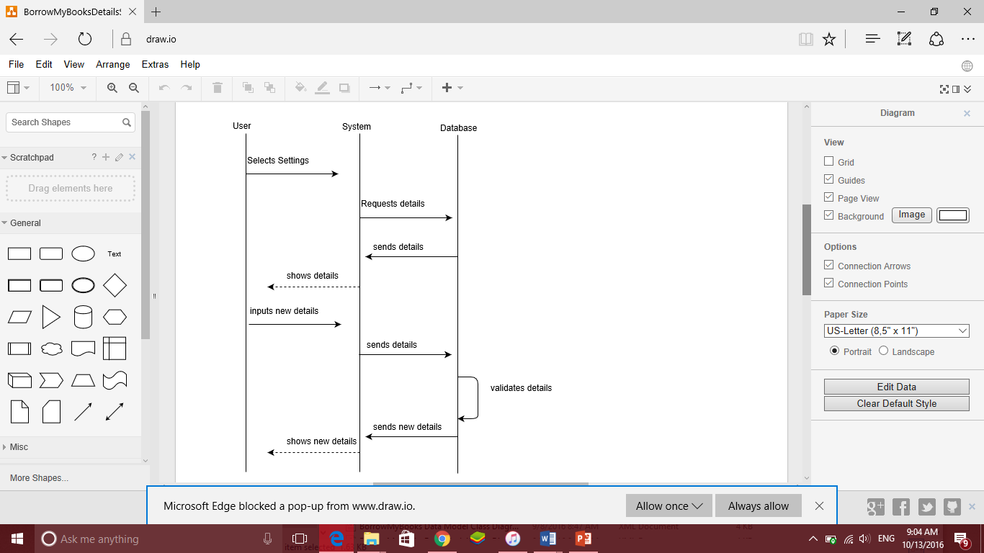

The user needs to update their details on the system. They select the ‘settings‘ option on the page which then query’s the user’s existing details from the database. These details are displayed to the user on the page. The user can then enter their new details and send them through. The system processes the details and forwards them to the database where these new details are stored. Data validation is performed and the new details are stored, if valid, in the database. The user is then notified by the system of the successful update.

# Discount Evaluation Sequence Diagram:

The following sequence diagram shows the process which the system follows in order to determine a discount for a purchaser.

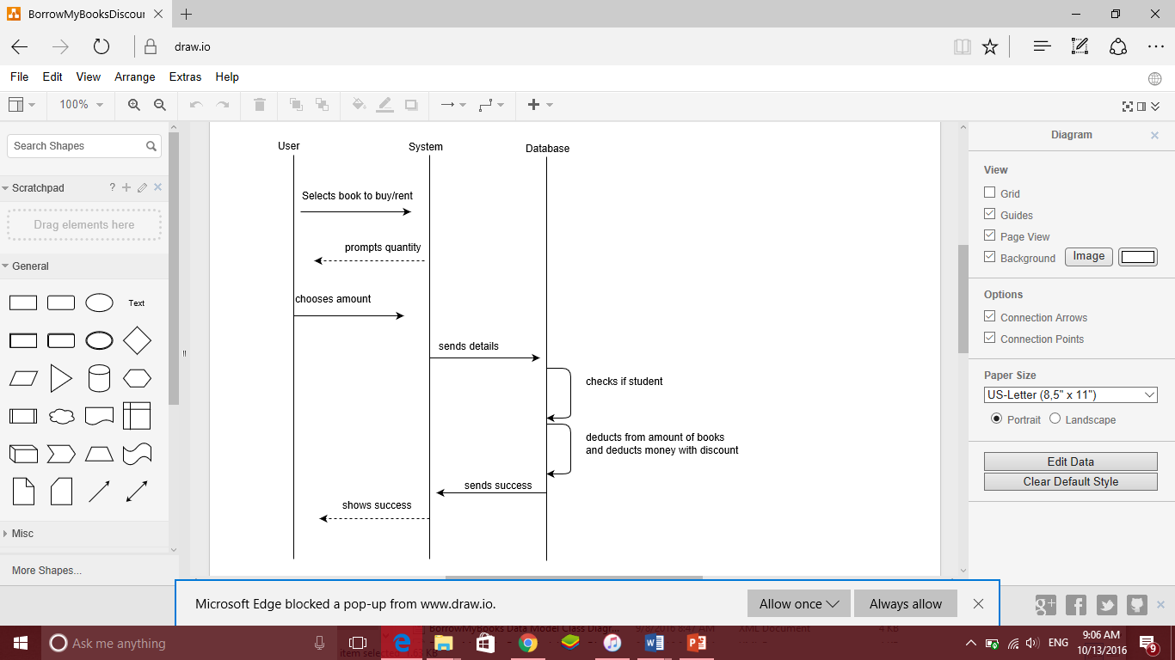

The user selects a book to buy or rent on the page. The system then prompts the user to enter the quantity of the books required by the user. These details are then sent to the database. The database checks to see if the user is a student. If so, the number of remaining available books in the database is updated and the value of the transaction made by the user is deducted from the user’s account, less the discount calculated by the database. The user is then notified of the successful transaction by the system.

# Explore Sequence Diagram:

The following sequence diagram shows the process of the Explore page being populated on the site.

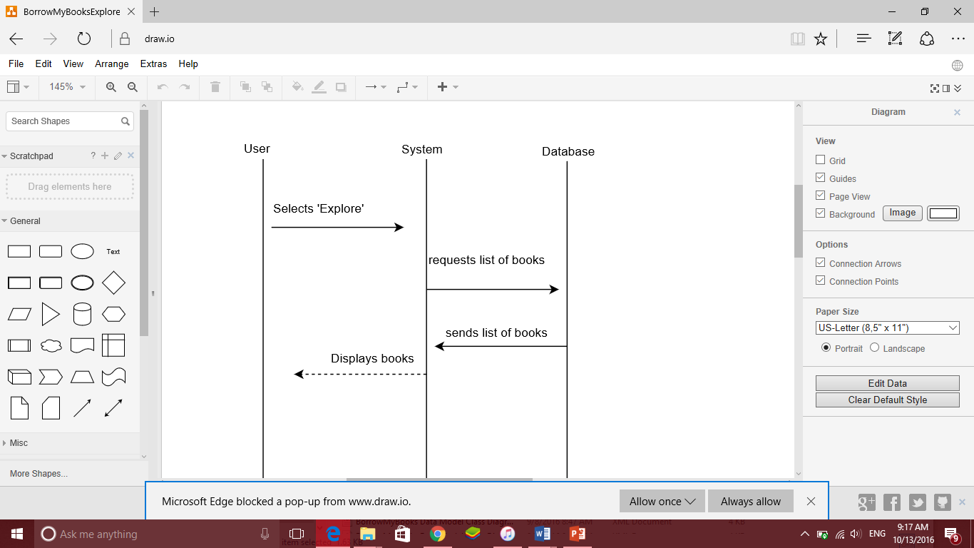

The user selects the ‘explore’ button on the site. The system then requests the list of books and their details from the database. The database returns all these details and the system displays the books once loading the explore page on the user’s side of the system.

# Loan Sequence Diagram:

The following Sequence diagram shows the process followed by the stakeholders when a user requests to upload a book for loaning on the system.

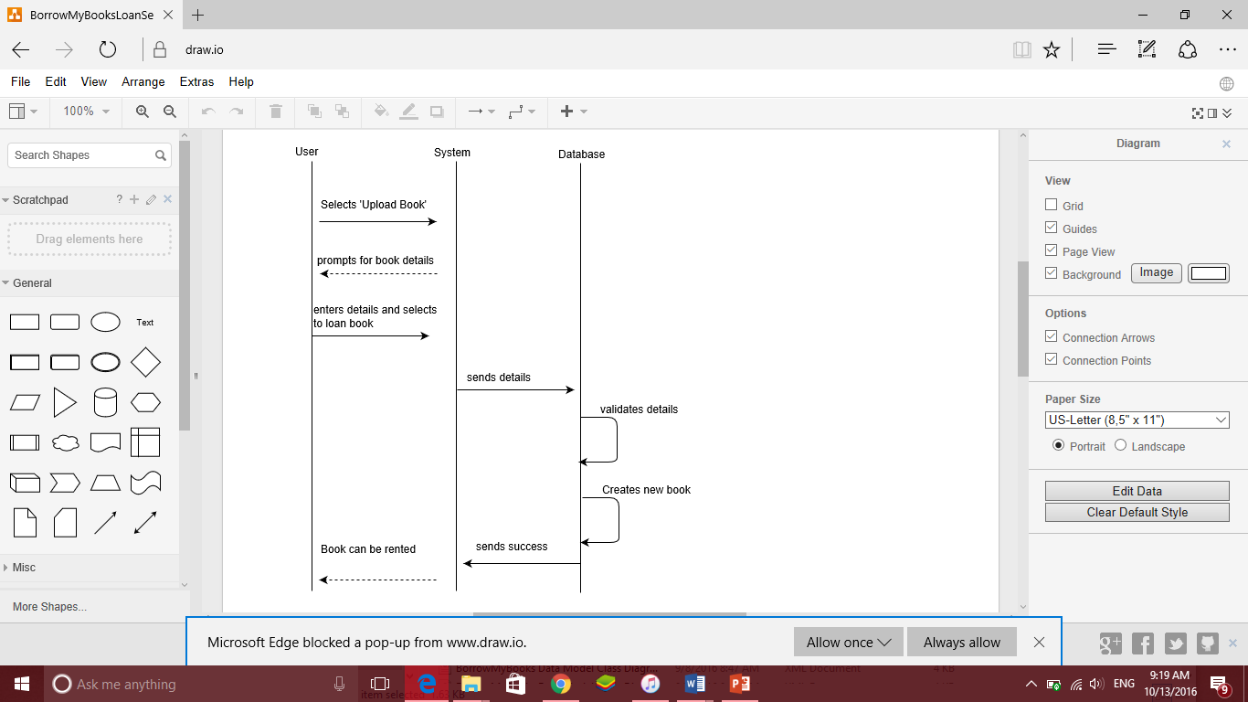

The user requests to upload a new book. The system requests all the details of the book from the user. It then sends the details, once entered, to the database. After data validation is performed on the details, the database creates a new book in the datastore and responds with a success message to the system. The book can now be rented out to other users.

# Login sequence diagram:

The following Sequence Diagram shows the process followed by the system when a user requests to login.

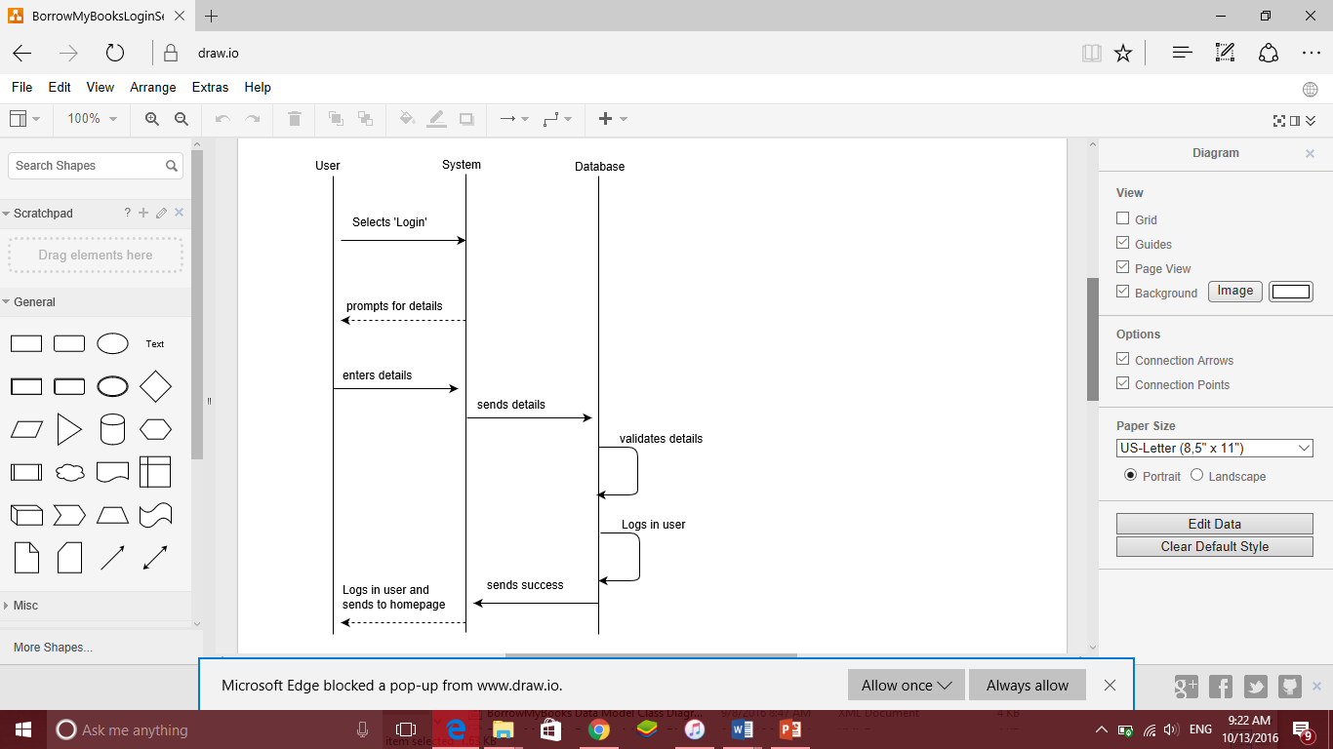

The user requests to login to the system. The system processes the submitted login details and sends them to the database. If the validation of the credentials is successful, the database logs the user in. The system is notified by the database of the successful login attempt, and the user is redirected to the home page.

# Logout sequence diagram:

The following sequence diagram depicts the process of a user logging out of the system.

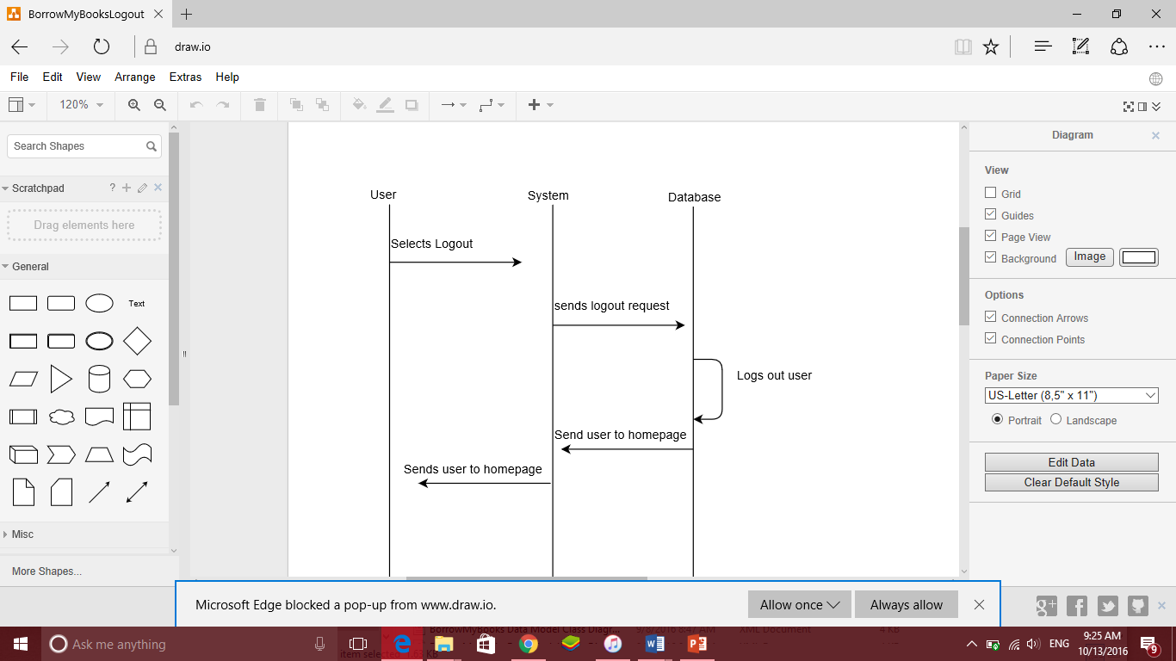

The user selects the logout button. The system then sends a logout request to the database, which logs the user out and sends a notification to the system that the user must be sent to the homepage. The system then redirects the user to the homepage.

# Profile Sequence Diagram:

The following sequence diagram shows the process of the system displaying a users details upon request.

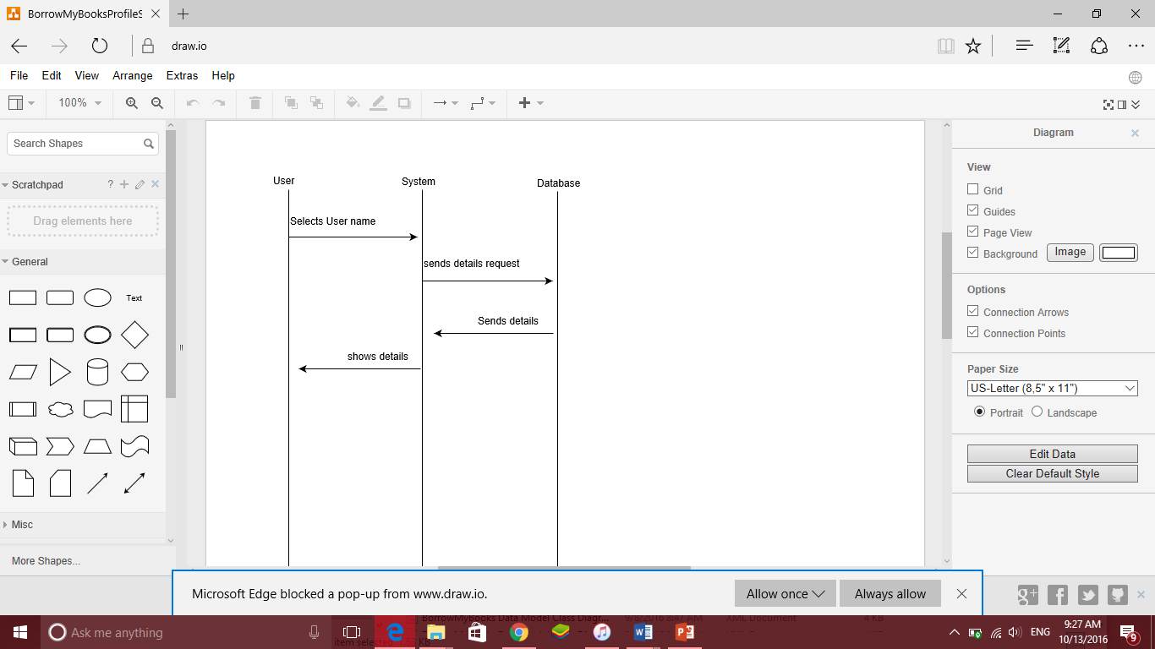

The user selects their name on the system page. The system then requests their details from the database, which responds with all the user’s details. The system then displays these details to the user.

# Rent sequence diagram:

The following sequence diagram shows the process of a user renting a book out from the system.

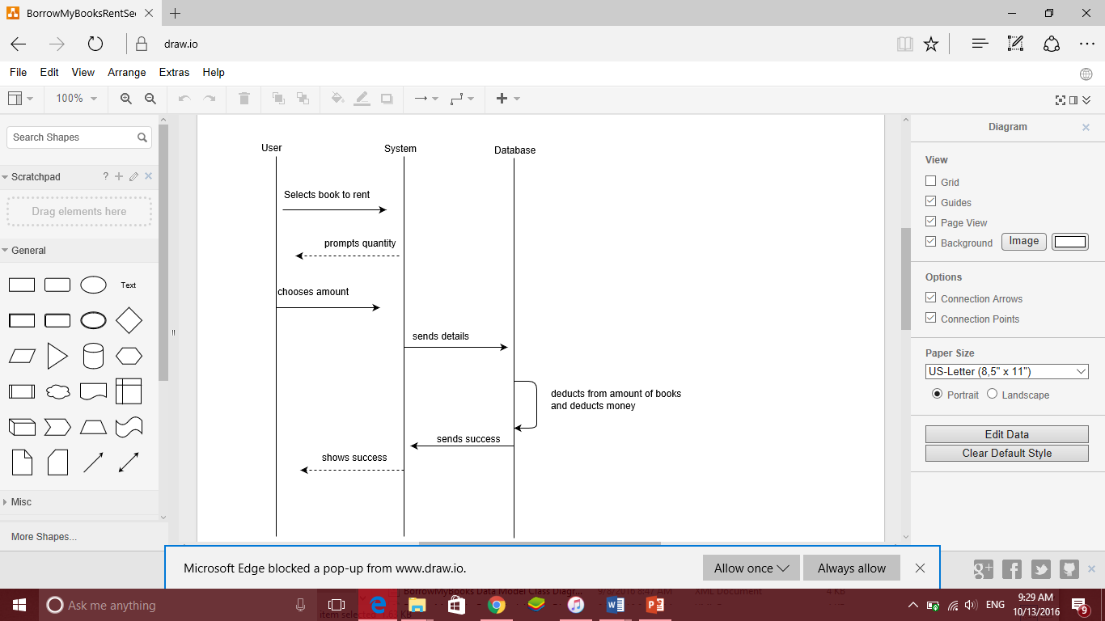

The user selects the book which they would like to rent out. They are then prompted for the quantity by the system. Once the quantity is entered, the system sends the details to the database. The database then reduces the availability of the book and monetary value from the datastores accordingly.

The system is then sent a success notification, which is forwarded to the user.

# Report User Sequence Diagram

The following sequence diagram shows the process followed by a user to report another user through the system.

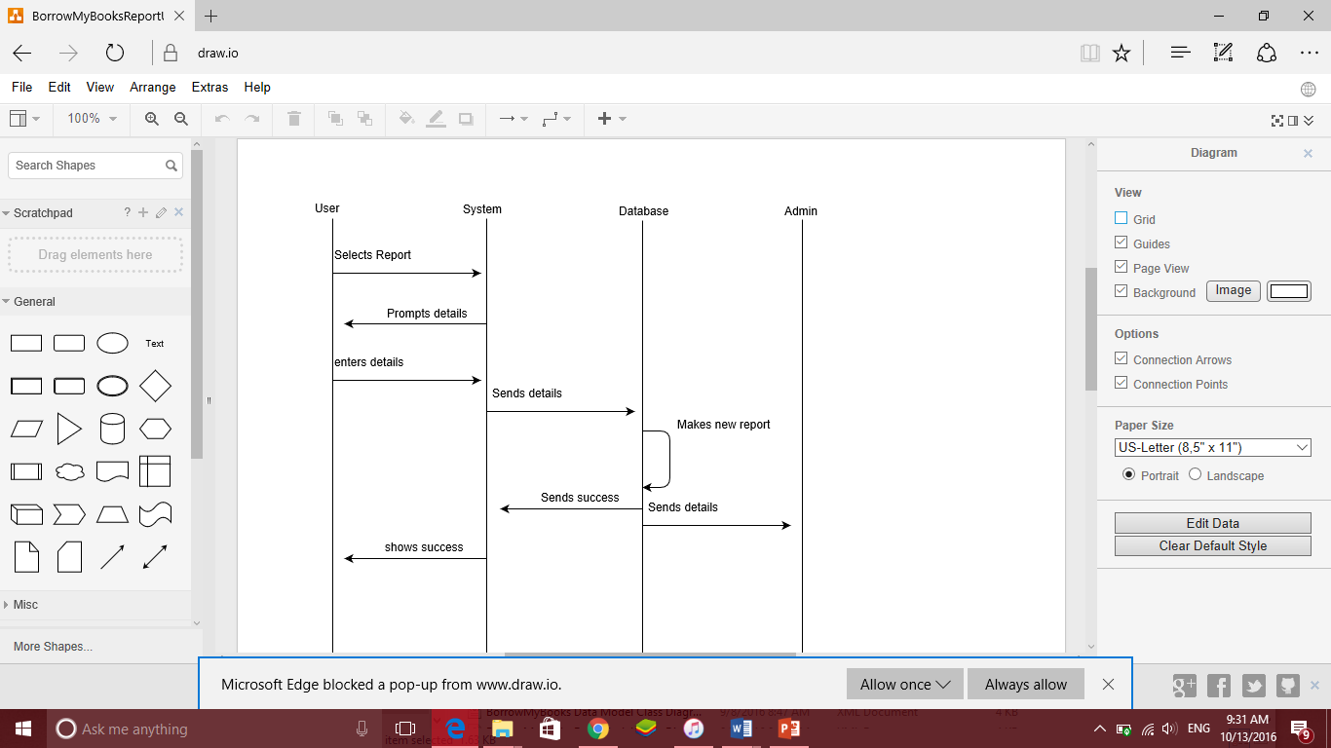

The user requests to report another user on the system. The system requests the details of the other user. These details are then forwarded to the database, which generates the report and sends it to the administrator. The user is notified of the report creation.

# Reset Password sequence diagram:

The following sequence diagram describes the process followed by a user that wishes to reset their password.

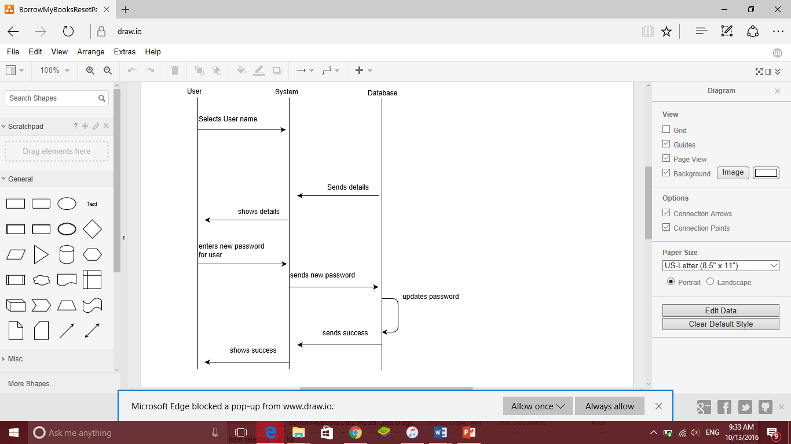

The user selects their user name on a system page. The database then returns the users details, and the system displays the details on the user’s screen. The user then enters their new password, which the system sends to the database. The database updates the existing password and the user is notified of the successful update.

# Reverse Transaction Sequence Diagram

The following sequence diagram shows the process followed for a transaction on the system to be reversed.

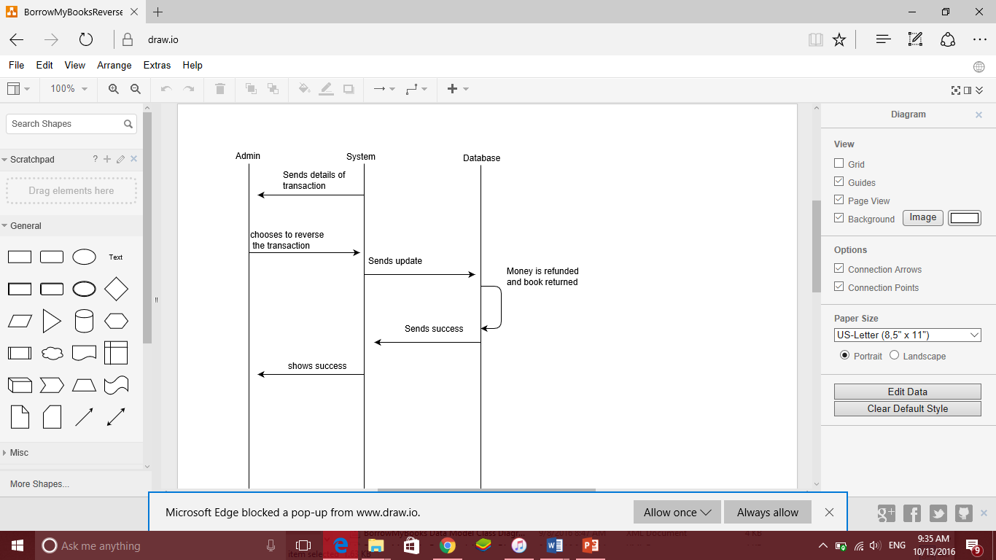

The system sends the details of the transaction to the administrator. The administrator selects to reverse the transaction. The update is sent to the database and the money is refunded to the user, and the book is added back into the database. The administrator is then notified of the successful reversal.

# View uploaded books sequence diagram:

The following sequence diagram shows the process followed to display the books uploaded by a user.

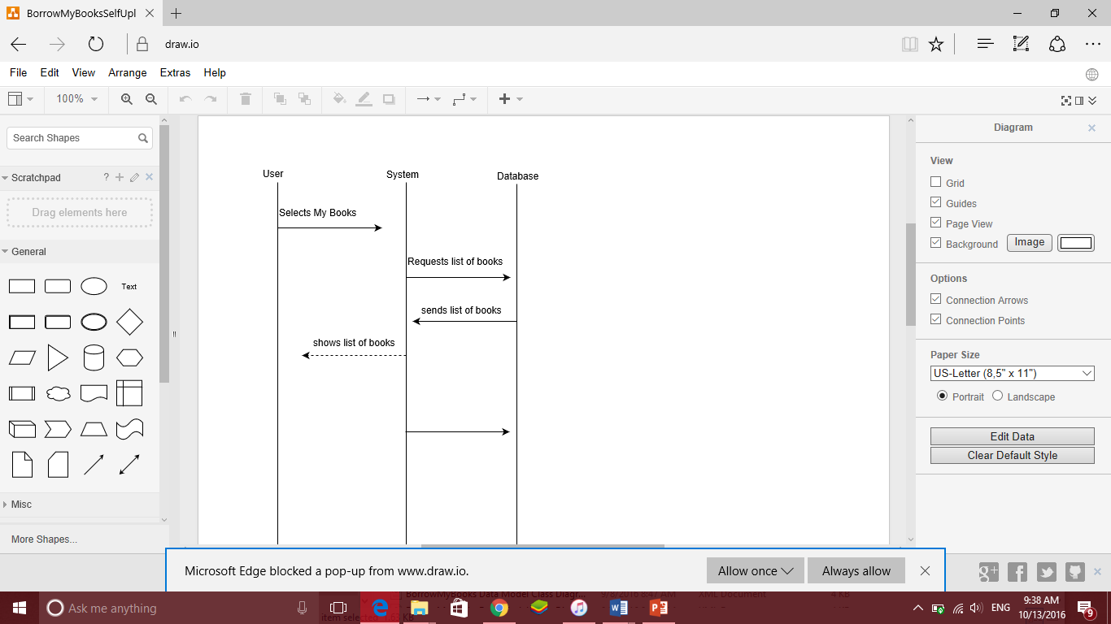

The user requests to view all the books they have uploaded. The database returns all the details of these books and displays them to the user through the system.

# Sell sequence diagram

The following sequence diagram shows the process followed in the system when a book is being uploaded to be sold.

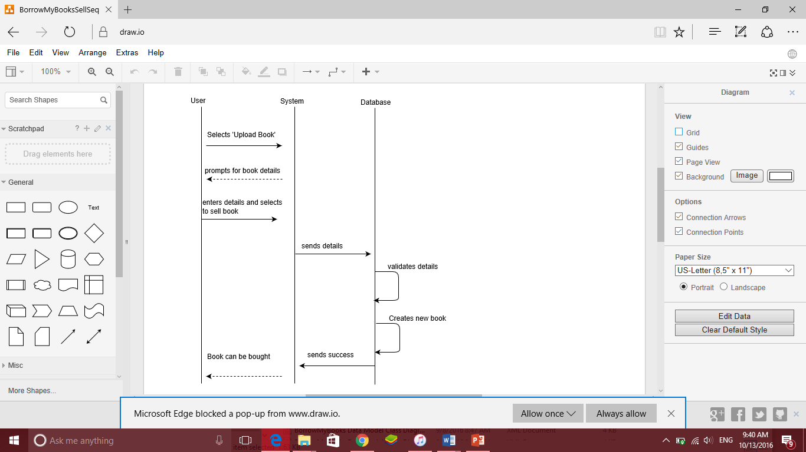

The user selects the ‘upload book’ option. The user then enters all the details of the book which are then sent to the database. The database validates the data and creates a new book in the book datastore. The system is notified of the successful creation of the book which is then forwarded to the user.

# Sign up sequence diagram:

The following sequence diagram shows the process followed to sign a new user up on the system

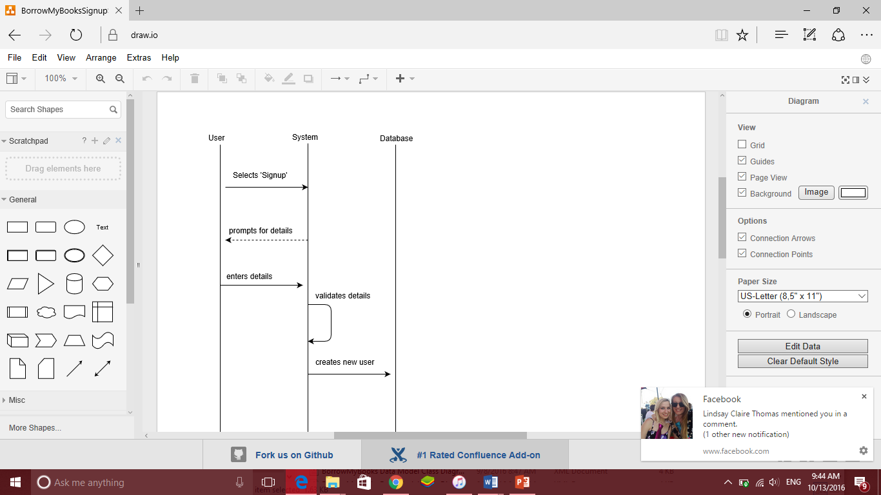

The user selects the option to sign up. They enter their details onto the system, where the system validates them and sends them to the database. The new user is then created and stored in the datastore.

# System defaults sequence diagram

The following diagram shows the process followed to update the system defaults on a user’s browser.

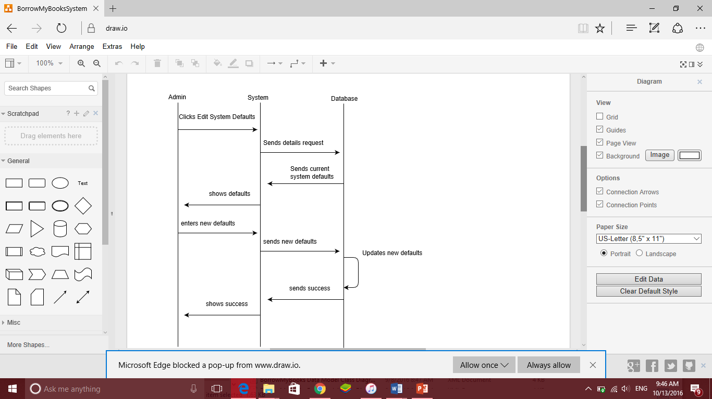

The user selects the system defaults option. The details are returned from the database and displayed to the user by the system. The user enters the new defaults preferences and these are sent to the database by the system. The system and user are then notified of the successful update.

# System information sequence diagram

The following diagrams shows the process of requesting the system information.

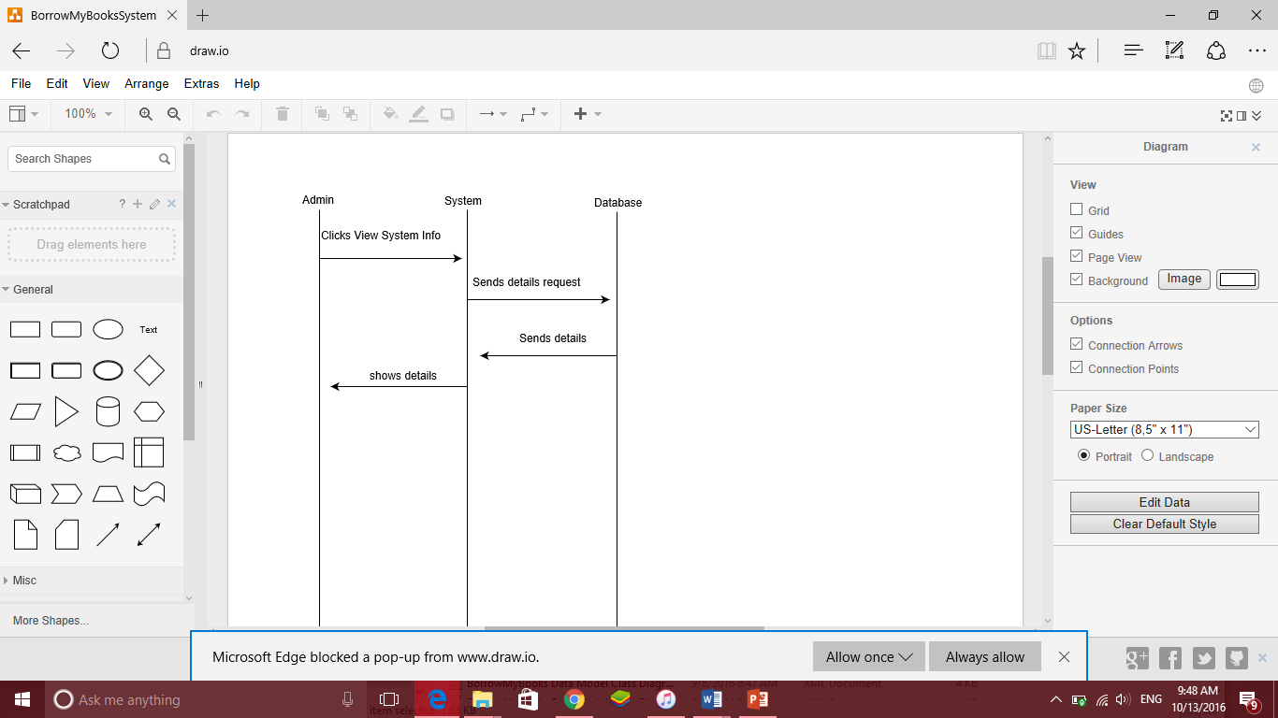

The administrator chooses to view the system information. The system requests the system information from the database and these details are sent to the system. They are then displayed to the adminstator.